Well, well, well. The “AI will replace doctors” debate, which, as my paid subscribers know, I’ve been chronicling since Warner Slack’s automated patient questionnaire in 1955, just got its most prestigious endorsement yet.
Yesterday, August 17, 2026, JAMA published a Perspective titled “Will Autonomous AI Exceed AI-Aided Physicians as the Best Medical Care?” (Translation: not a study. An opinion piece.) The authors answer their own question with two words: “We disagree.” Not with the premise, but with the medical establishment. The AMA, the American College of Physicians, and Robert Wachter’s new book all conclude AI should assist doctors. The authors say AI alone is “likely to be better” than doctors, and better than doctors using AI, at 5 fundamental cognitive medical tasks. And they say the switch could be ready “in some, maybe many, workflows by 2030.”

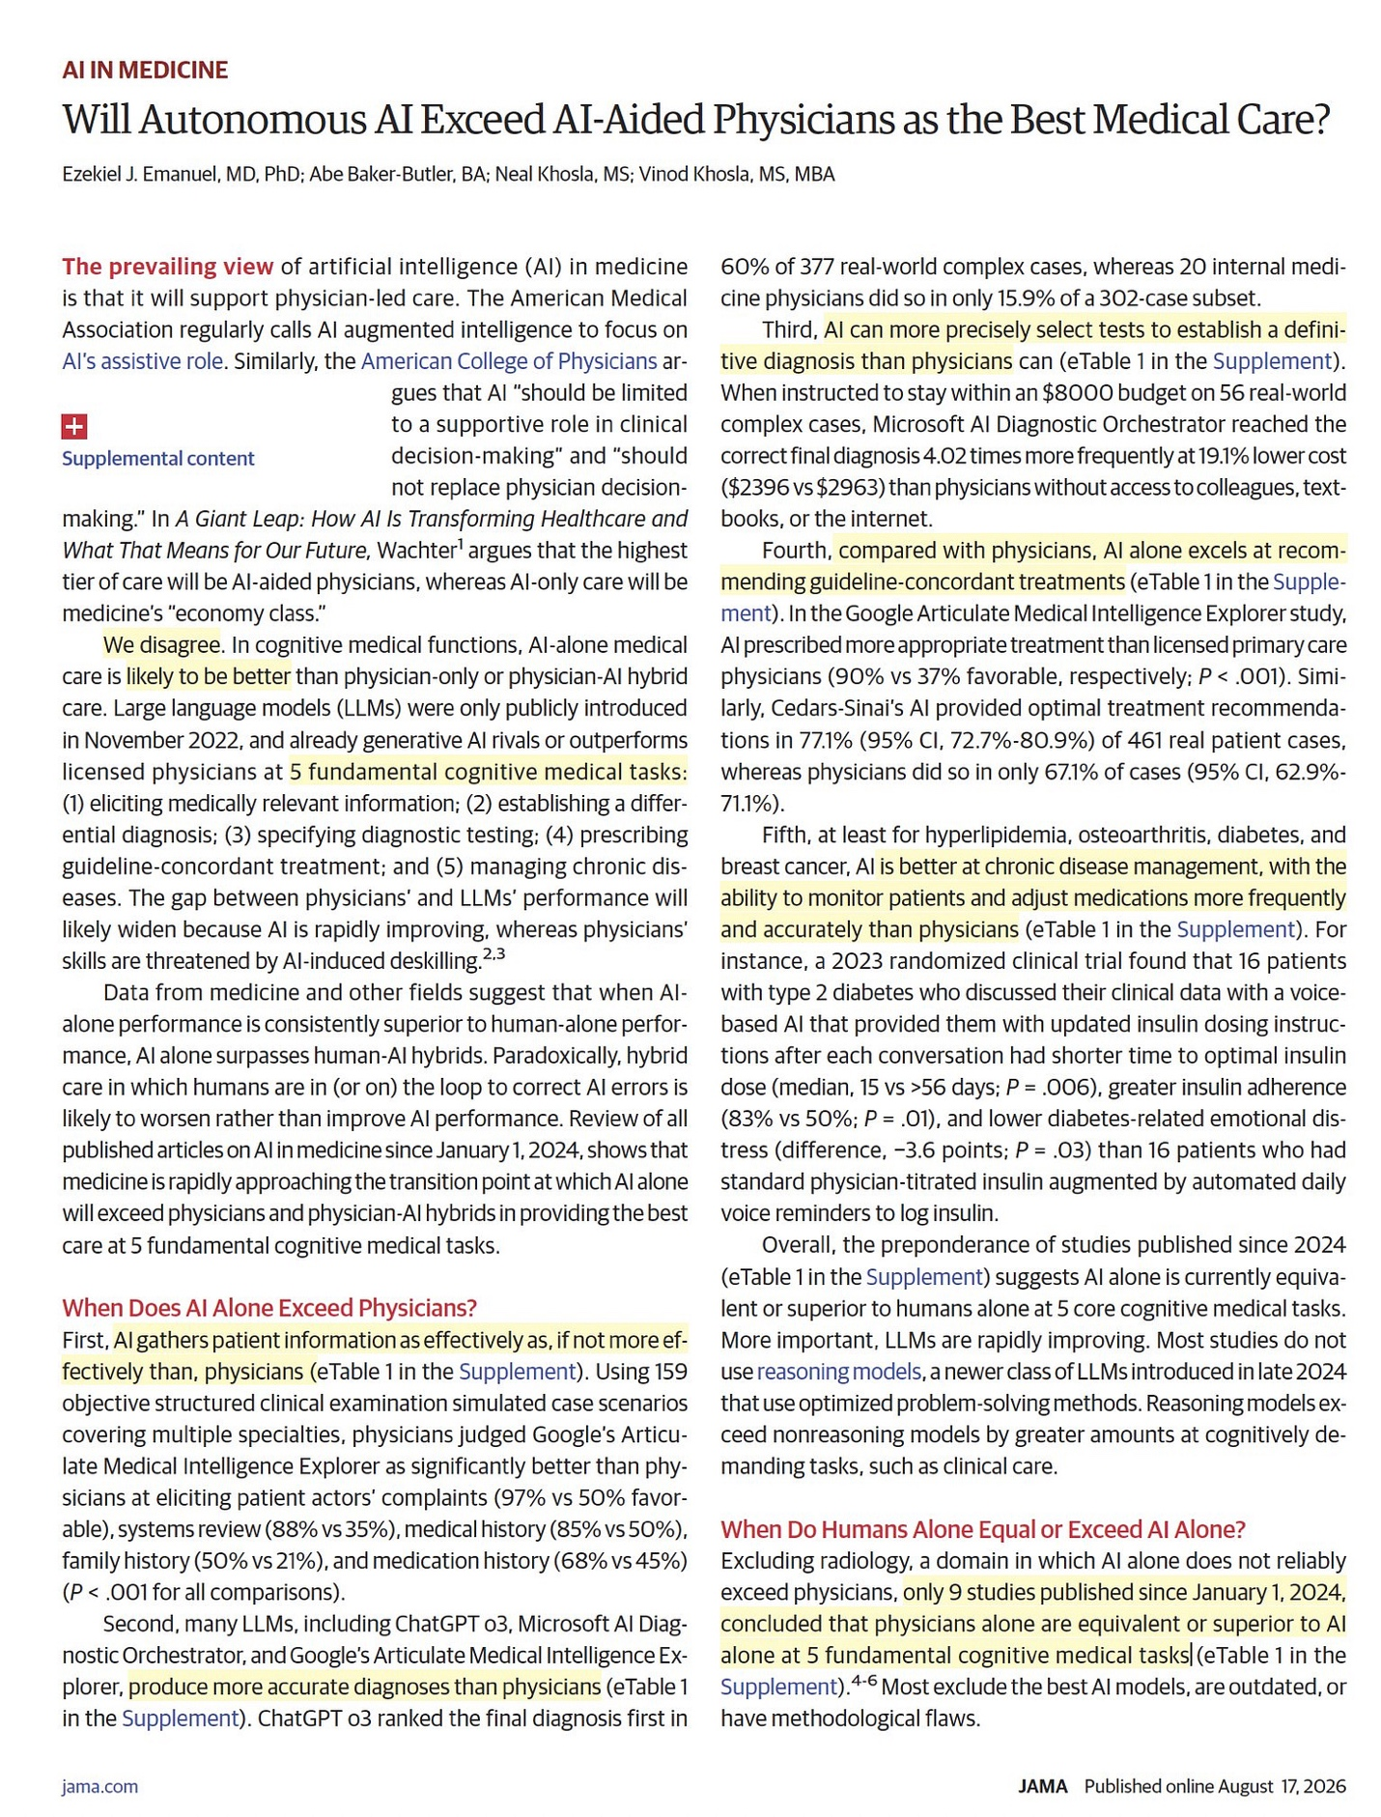

Who are these bold authors? Ezekiel J. “Zeke” Emanuel, oncologist, bioethicist, architect of the ACA (aka Obamacare), who in 2016 added a second career as venture partner at a multibillion dollar healthcare investment fund (we’ll get to that). Abe Baker-Butler, Emanuel’s research fellow at Penn and co-first author. Neal Khosla, CEO of Curai Health, an autonomous-AI primary care company. And Vinod Khosla, Neal’s father, billionaire founder of Khosla Ventures, early OpenAI investor, and the man who has been predicting the end of doctors since 2012 with the consistency of a Swiss watch and the accuracy of a Magic 8 Ball. 🎱
My longtime paid subscribers know where I stand, because I laid it out across my 6-part series on this exact debate. I am not a doctor-protectionist. In Part 4, I made what might be the most comprehensive case yet FOR the “AI will replace doctors” argument, and I ended it with “Wake up, America. It’s time to embrace AI in healthcare.” I meant every word. I have also publicly predicted that fully autonomous AI diagnosis, with no human in the loop, is coming.
So no, I’m not here to tell you the Khoslas are wrong about the destination.
I’m here to tell you that this JAMA article is not the vehicle that gets us there. It’s a pitch deck wearing a lab coat.
TL;DR:
1. What Exactly JAMA Published Yesterday
2. Follow the Money: An Author List That Doubles as a Cap Table 💰
3. Task by Task: Their Evidence Under the Microscope 🔬
4. The “Humans Drag Down AI” Claim: Same 6 Vignettes, New Wrapper
5. A Chess Blog Walks Into JAMA ♟️
6. The Curai Sideshow: 91% of What, Exactly?
7. Emanuel vs. Emanuel, and 14 Years of Khosla Predictions
8. Silver Linings: Where the Authors Are Right
9. My Peer Reviewer Wish List
10. Conclusion

1. What Exactly JAMA Published Yesterday
The argument goes like this. Generative AI already rivals or beats licensed physicians at 5 cognitive tasks: (1) eliciting medical information, (2) differential diagnosis, (3) selecting diagnostic tests, (4) prescribing guideline-concordant treatment, and (5) managing chronic disease. Meanwhile, physicians are getting worse, “threatened by AI-induced deskilling.” And here’s the twist that makes this paper different from the hundred hype pieces before it: when AI alone beats humans alone, the authors argue, putting a human in the loop makes things WORSE. Hybrid care, the sacred “physician + AI” model that every health system, medical society, and hospital marketing department has bet on, is framed as a transitional arrangement that degrades AI performance.
In other words: the doctor isn’t the pilot. The doctor is the turbulence.
Give the authors credit for one thing. They said the quiet part out loud, in the most-read medical journal on Earth, under their real names, with their conflicts disclosed. That is more than I can say for the army of anonymous “AI will replace doctors” reply guys on X. Forbes covered the paper within hours. So did Medical Economics. The hype cycle is already spinning.

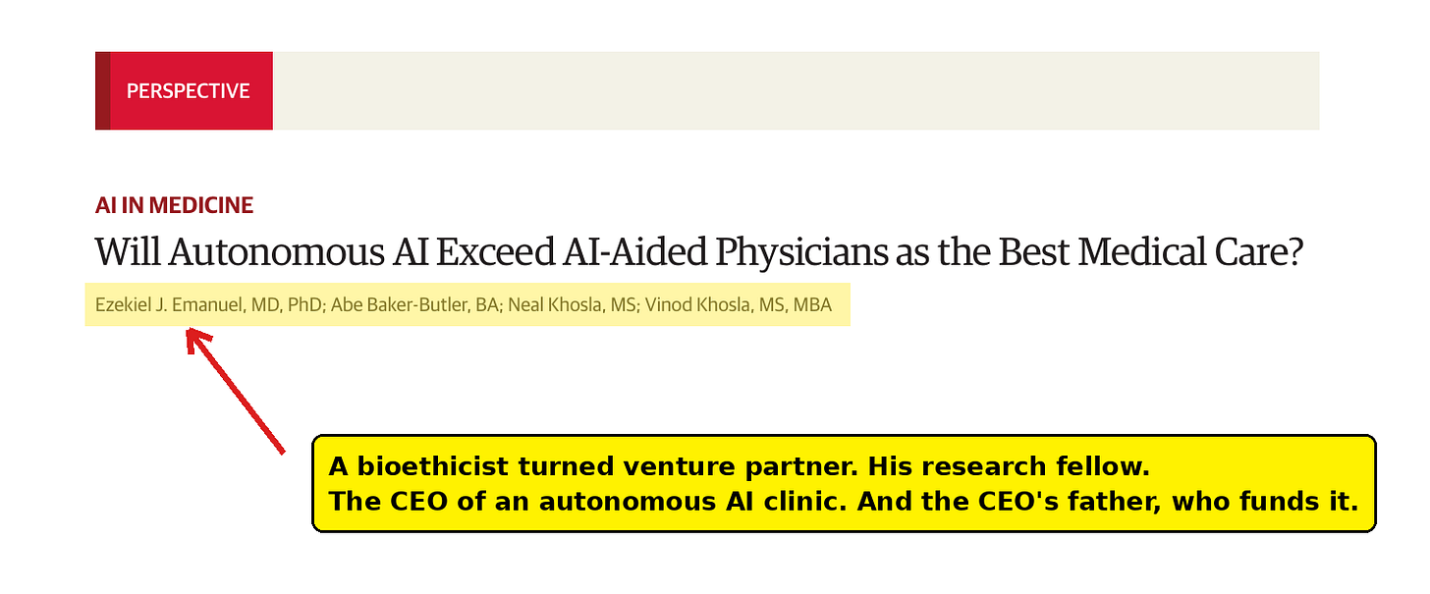
Published online in JAMA yesterday, August 17, 2026. Annotation is mine.
And unlike the notorious 6-vignette study from November 2024 that I tore apart in Part 2 of my series, this isn’t a study at all. It’s a Perspective. An opinion piece. There are no methods, which is convenient, because there’s nothing to check. Except there is. The piece cites roughly two dozen studies as its evidence base, plus two supplemental eTables assembled from a “review of all published articles on AI in medicine since January 1, 2024.”
Conducted by whom? With what search strategy? Screened by what criteria? Graded by whom? The Perspective doesn’t say. A review of “all published articles” in the hottest field in medicine, condensed into two eTables, with no stated methodology, in a paper arguing we should trust AI more and human judgment less. The irony writes itself. 😉
So let’s do what peer reviewers apparently no longer do. (As a peer reviewer myself, I find that particularly troubling.) Let’s read the evidence.
This is not a literature review. This is a portfolio review.

2. Follow the Money: An Author List That Doubles as a Cap Table 💰
I want to be precise here, because precision is exactly what’s missing from most coverage of this paper. Nobody hid anything. The conflict-of-interest section is right there at the end.

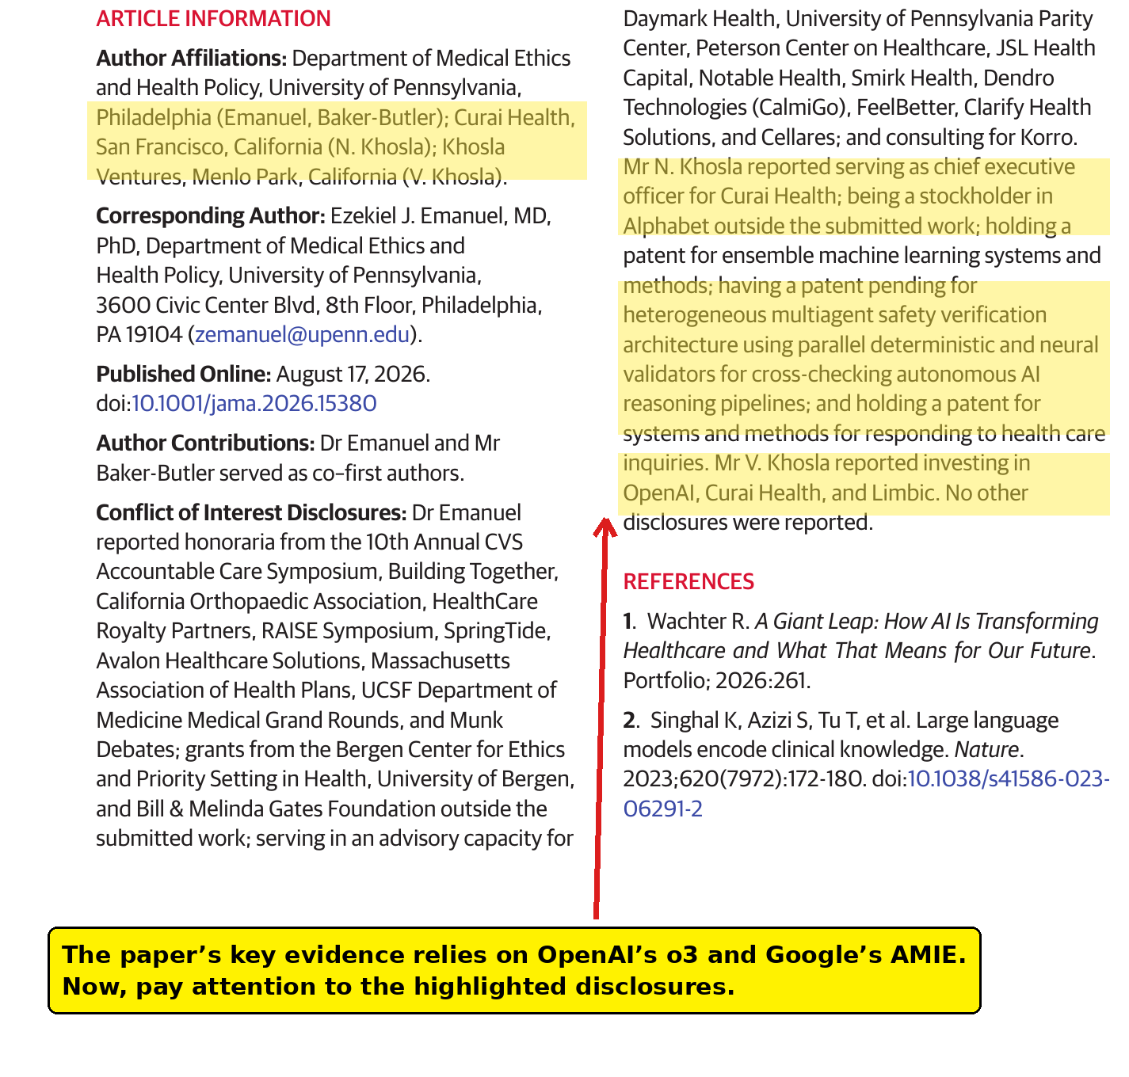
The Conflict of Interest Disclosures, straight from the paper. The highlights and the yellow box are mine.
Vinod Khosla “reported investing in OpenAI, Curai Health, and Limbic.” That’s the paper’s own disclosure. Khosla Ventures famously wrote one of the first venture checks into OpenAI back in 2019. Vinod is also, per Forbes, worth about $13.5B.
Neal Khosla is the CEO of Curai Health, an autonomous-AI primary care company his father backs. He also disclosed being a stockholder in Alphabet, holding a patent for “systems and methods for responding to health care inquiries,” and having a patent pending for a “heterogeneous multiagent safety verification architecture using parallel deterministic and neural validators for cross-checking autonomous AI reasoning pipelines.”
Say that five times fast. Then ask yourself whether the conclusion of this Perspective was ever in doubt. A man with a pending patent on autonomous-AI safety verification co-authored a paper concluding that autonomous AI is safe to run without human verification. 🤯
Ezekiel “Zeke” Emanuel disclosed honoraria from ten organizations, advisory roles at ten more (including health-AI and health-tech companies like Notable Health, Clarify Health Solutions, FeelBetter, and a health investment outfit called JSL Health Capital), and consulting for Korro. What the disclosure does not mention: in January 2016, Oak HC/FT, a multibillion dollar healthcare venture fund, announced Emanuel as a Venture Partner, and as recently as April 2022 the Philadelphia Inquirer profiled “the latest chapter of Ezekiel Emanuel’s career” as a venture capitalist. Maybe that chapter quietly ended and the bio pages didn’t get the memo. Maybe it didn’t. Either way, the man evaluating whether AI companies should take over the work of physicians has spent a decade around the table where healthcare startups get funded. Readers deserved that sentence in the disclosure, not in my newsletter.
Abe Baker-Butler is Emanuel’s research fellow at Penn’s Department of Medical Ethics and Health Policy and, to his credit, appears to be the one author without a term sheet. Congratulations, Abe. Guard that innocence. 😊
The thesis of the entire paper, that autonomous AI should see patients without physician oversight, happens to be the business model of Curai Health, whose CEO is an author and whose investor is his co-author and father.
Every load-bearing study in this Perspective runs on a model built by a company in which at least one author holds a financial interest. Again: disclosed, transparent, legal. JAMA followed its process. But disclosure is not absolution. It’s a warning label.
And the label on this paper reads: the people telling you doctors make AI worse are the people who profit when you believe it.
As I asked in Part 4, when Bill Gates and Apple joined the replacement chorus: should doctors start packing? Depends how attached they are to stethoscopes. 😉

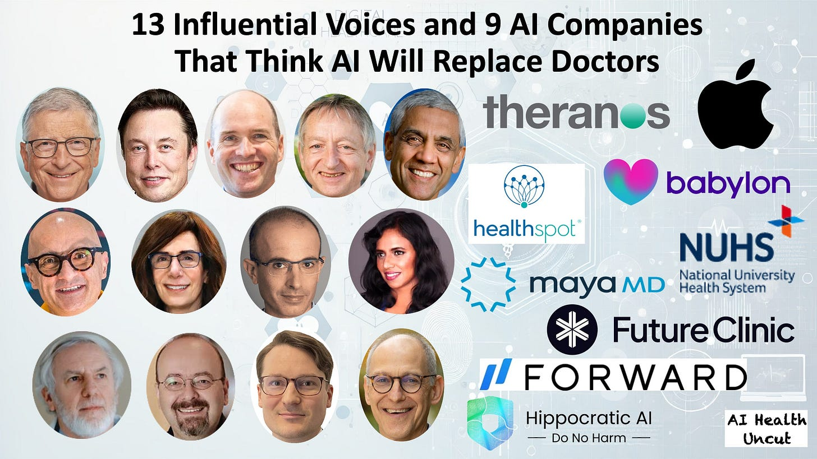
The Part 4 lineup, April 2025. Two of the four authors of yesterday’s JAMA Perspective were already on this poster. You have to admire the consistency.
But before anyone packs anything, let’s check the evidence the way I checked the last “AI beats doctors” paper. Spoiler: it rhymes.

3. Task by Task: Their Evidence Under the Microscope 🔬

3.1. Task 1: Eliciting Patient Information. Simulated Patients, Simulated Victory.
The claim: “AI gathers patient information as effectively as, if not more effectively than, physicians.” The evidence: Google’s AMIE study in Nature, where physicians rated AMIE better than primary care physicians at eliciting complaints (97% vs 50% favorable), systems review (88% vs 35%), medical history (85% vs 50%), and so on.
What the Perspective doesn’t tell you: those were 159 SIMULATED objective structured clinical examination scenarios. Patient actors. Text chat. The PCPs were typing to fake patients in a chat window, a consultation format approximately zero practicing physicians use, while AMIE was purpose-built for exactly that format. The Nature paper it self flags this limitation. It’s like racing a fish against a cat and concluding cats can’t swim... wait, reverse that. You get the idea. 😊

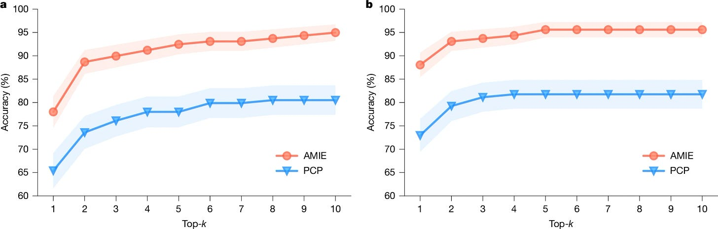
Key figure from the AMIE study
You know what happened when Google took AMIE out of the simulator? In its real-world feasibility study at Beth Israel Deaconess, published in March 2026, AMIE’s top-1 diagnostic accuracy on 100 real patients was 56%. With a physician supervisor watching every interaction live on video, ready to pull the plug. To Google’s credit, that’s careful, honest science. It’s also a far cry from “AI gathers information better than doctors, ship it.”
Funny thing. The pro-AI camp can’t even agree on this task. In their February 2025 New York Times op-ed, the one I answered in Part 3, Topol and Rajpurkar argued the opposite: that when AI gathered patient information through direct interviews, diagnostic accuracy plummeted, in one case from 82% to 63%, so doctors should do the interviewing and hand the data to AI for analysis. Emanuel and the Khoslas now say information gathering is AI’s strong suit. Something’s gotta give.


Cover illustration for the February 2025 New York Times op-ed by Eric Topol and Pranav Rajpurkar. The annotation in red is mine.
Actually, scratch that. Within hours of the paper going live, Topol reacted:

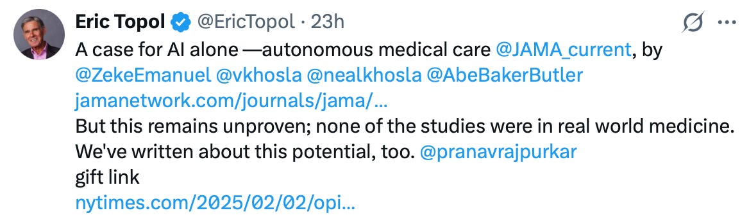
Eric Topol, August 17, 2026. The paper is unproven, the studies are not real world medicine, and here is a gift link to his own op-ed on the same potential. Everyone is a critic. Everyone is also an author.
Read what he wrote. The case “remains unproven” because “none of the studies were in real world medicine.” That is Eric Topol, arguably the most famous AI-in-medicine optimist on the planet, and the man my Part 3 was addressed to, saying about this JAMA Perspective more or less what this article says at ten times the length. When even Topol looks at your autonomous-AI evidence and reaches for the word “unproven,” the evidence is thin. And yes, he attached a gift link to his own February 2025 op-ed in the same tweet. In this debate, nobody criticizes a paper without plugging one. Myself included, I suppose. 😊
Oh, and one more thing. The Perspective’s own citation number 23, Bean et al in Nature Medicine, found that “transmission of information between the LLM and the user…[is] a particular point of failure.” Their own reference says the leading failure mode of medical LLMs is the exact task they lead with. Interestingly, they quote it in the caveats section and keep the conclusion anyway.

3.2. Task 2: Diagnosis. Zebras Only, No Textbooks Allowed.
The claim: LLMs “produce more accurate diagnoses than physicians.” The star exhibit: ChatGPT o3 ranked the correct final diagnosis first in 60% of 377 real-world complex cases, versus 15.9% for 20 internal medicine physicians on “a 302-case subset.”
Read that sentence again. The model gets graded on 377 cases. The physicians get graded on a 302-case subset. Two different denominators in one comparison, in one sentence, in JAMA. As a quant, I have questions. As a peer reviewer, I’d have red ink.
And what were these cases? The same genre as Microsoft’s AI Diagnostic Orchestrator benchmark: diagnostic puzzle cases, the medical equivalent of chess problems, the kind of presentation most physicians see a handful of times in an entire career. As Dr. Graham Walker pointed out when I covered this genre in Part 2: every sane doctor asks for help on cases like these, because they’re selected to be the cases where doctors need help. Meanwhile, the physicians in the Microsoft comparison were, per the Perspective’s own words, “without access to colleagues, textbooks, or the internet.”
So, the humans were stripped of every tool a real physician uses hundreds of times a day, then compared to a machine with all of human medical literature baked into its weights, on cases hand-picked to be unsolvable without exactly that literature.
That’s not a study of clinical medicine. That’s a closed-book exam nobody practices in.
Now, about the studies pointing the other way. The Perspective admits “only 9 studies published since January 1, 2024” found physicians equal or better than AI, then dismisses them: “Most exclude the best AI models, are outdated, or have methodological flaws.”
Let’s take the one they name first, Hager et al in Nature Medicine. Dismissed because it “excluded the best AI models,” meaning OpenAI’s and Google’s LLMs. What they don’t tell you is WHY. Straight from the paper: “Data taken from the MIMIC database is currently prohibited from being used with external application programming interfaces (APIs), such as that of OpenAI or Google, due to data privacy concerns and data usage agreements.” The study used real electronic health records from 2,400 real patients with abdominal pain. Real records cannot be piped into OpenAI’s API under the database’s data use agreement. So the “flaw” that gets this study dismissed is that its authors followed patient privacy rules. And on those 2,400 real patients, physicians beat every tested LLM by 16% to 25%, with model performance collapsing further the moment models had to gather information themselves instead of receiving a pre-packaged case.

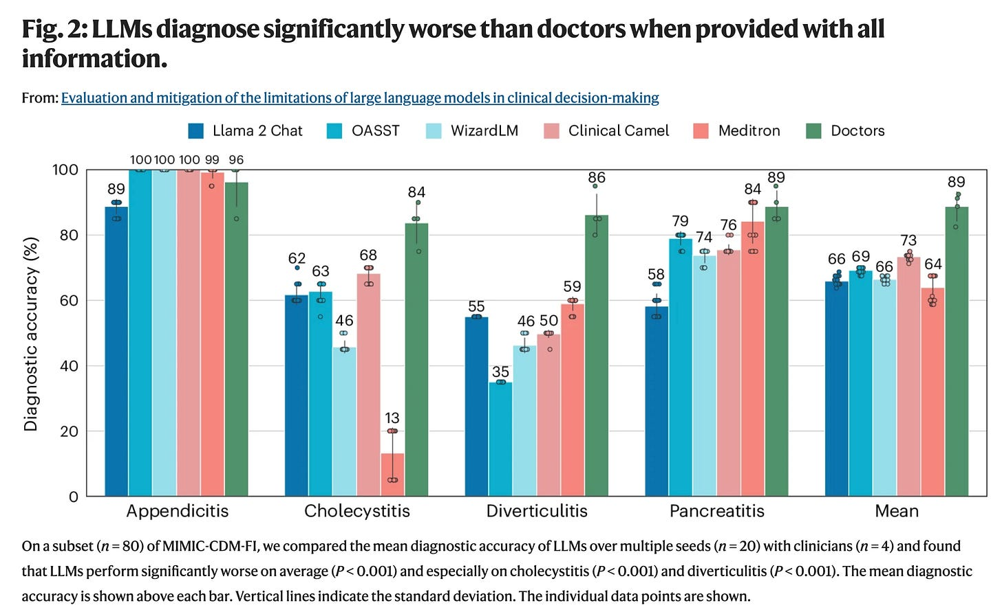
Key figure from the Hager et al study
Notice the pattern. Studies using curated puzzle-like vignettes where AI shines are cited at face value. Studies using real, messy, legally protected patient data where AI stumbles suddenly have “methodological flaws.” Methodological rigor for thee, but not for me. 😉

3.3. Task 3: Test Selection. Behold, the Number 4.02.
The claim: AI selects diagnostic tests more precisely and cheaply. The evidence: on 56 cases with an $8,000 budget cap, Microsoft’s orchestrator reached the right diagnosis “4.02 times more frequently at 19.1% lower cost ($2396 vs $2963).”
4.02 times. On 56 cases. Not “about 4 times.” 4.02. That third significant digit is doing Olympic-level weightlifting on an n of 56. Decimal points as a costume for confidence.
And the cost numbers are simulated list prices in a system with no insurance, no prior authorization, no site-of-care games, and no 340B arbitrage. If you believe an American diagnostic workup costs what the price list says, I have a chargemaster to sell you.

3.4. Task 4: Treatment. Grading the Suggestion Against the Decision.
Two exhibits here. First, AMIE again (90% vs 37% favorable), from the same simulated OSCE setup as Task 1. Moving on.
Second, and more interesting: “Cedars-Sinai’s AI provided optimal treatment recommendations in 77.1%... of 461 real patient cases, whereas physicians did so in only 67.1%.” This is Zeltzer et al in Annals of Internal Medicine, run on Cedars-Sinai Connect, the virtual urgent care platform Cedars-Sinai operates as a joint venture with K Health.
Here’s what the topline hides. It was a retrospective review of one month of visits, June 12 to July 14, 2024. The comparison was between the AI’s INITIAL recommendation and the physician’s FINAL decision. The physicians had the AI’s recommendations available on screen during those visits and, as the study concedes, may or may not have looked at them. So the “AI alone” arm isn’t alone, the “physician alone” arm isn’t alone either, and an initial suggestion is being graded against a final, accountable decision made with a live patient talking, coughing, and negotiating in real time.

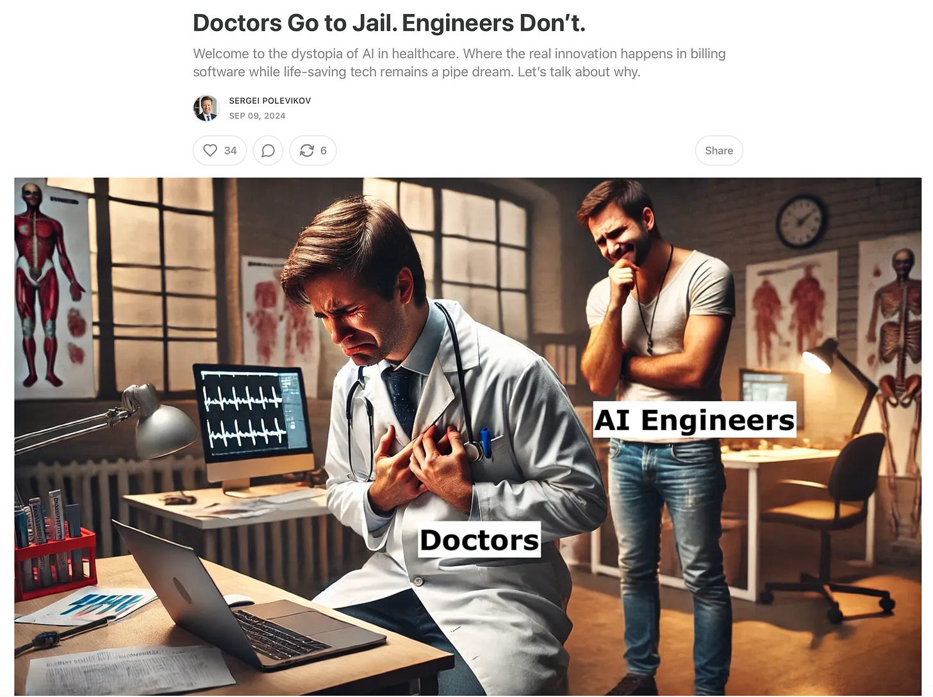

A suggestion is not a decision. A recommendation carries no liability. The physician’s name goes on the chart, the prescription, and the malpractice claim. As I’ve been saying for years: Doctors Go to Jail. Engineers Don’t.

3.5. Task 5: Chronic Disease Management. 16 Patients Per Arm.
The claim: AI manages chronic disease better, “at least for hyperlipidemia, osteoarthritis, diabetes, and breast cancer.” The showcased evidence: a 2023 randomized trial where 16 patients with type 2 diabetes used a voice AI for insulin titration versus 16 patients with standard physician titration.
Sixteen. Per arm. The confidence interval on a 16-person arm is wide enough to park a Mayo Clinic in. In Part 2, I wrote that a sample size of 6 is as good as a rumor, from a statistical standpoint. A sample of 16 is a slightly more confident rumor. From this, the Perspective generalizes to four disease areas covering a hundred-plus million Americans.
Any freshman majoring in statistics could tell you what’s wrong here. Apparently none were available at JAMA. Again. 🤦‍♂️

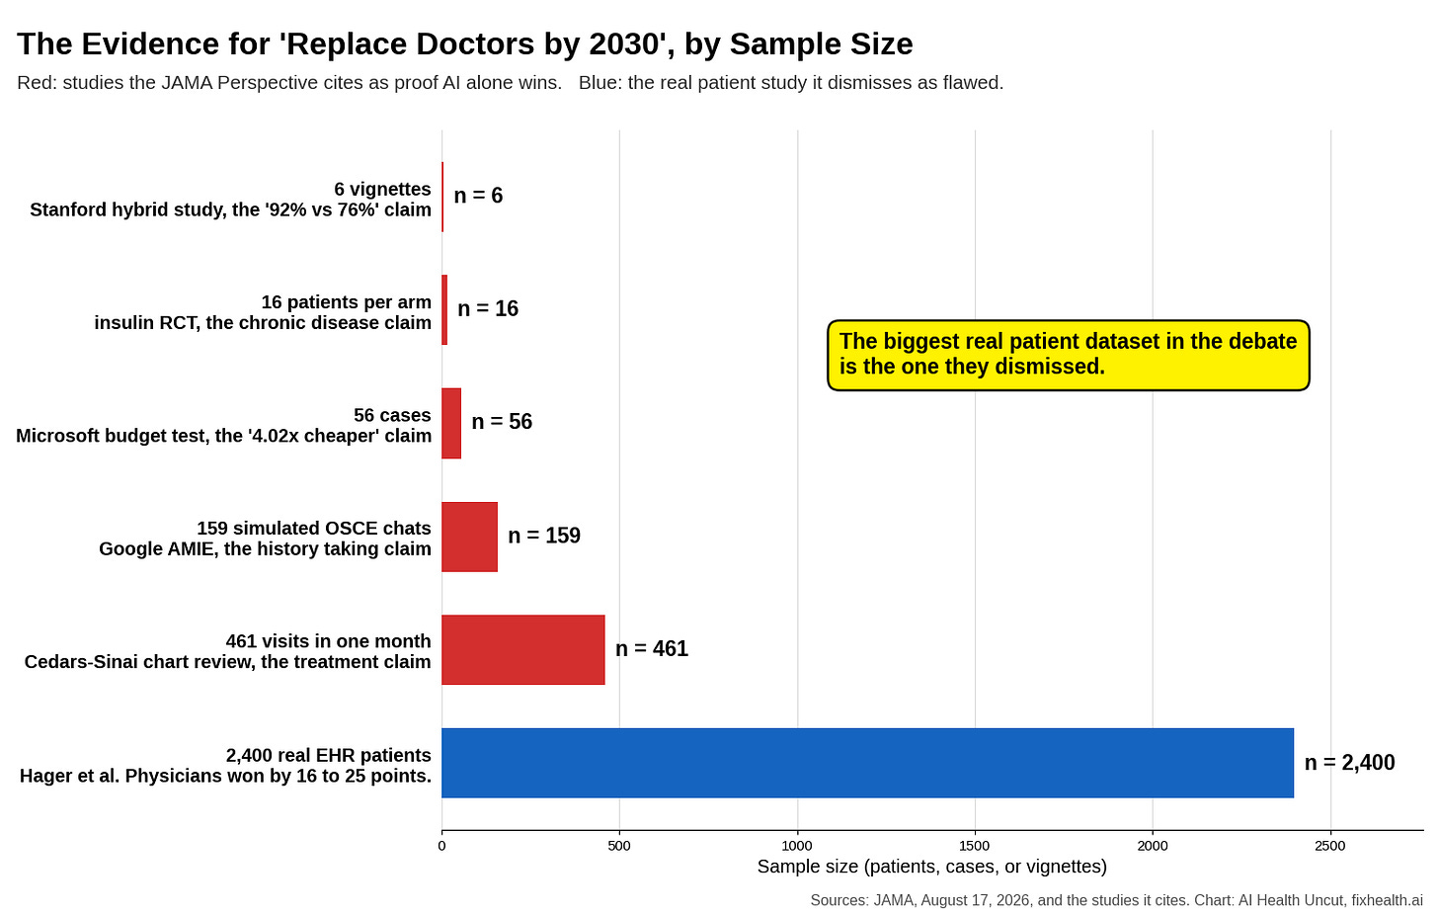
Every bar is a study the JAMA Perspective leans on, except the blue one, which is the study it waves away.

4. The “Humans Drag Down AI” Claim: Same 6 Vignettes, New Wrapper
Now we get to the paper’s actual innovation. Not “AI beats doctors.” That’s old news. The new claim is that doctors make AI WORSE. That hybrid care, the model every health system in America is betting billions on, degrades performance whenever AI alone is better than humans alone.
Exhibit A is a 2024 meta-analysis in Nature Human Behaviour of 106 human-AI experiments. When humans were better at a task, hybrids helped (g = 0.46). When AI was better, hybrids hurt (g = -0.54). Sounds devastating until you read the fine print the Perspective itself provides: “at least 20 were in medicine.” Meaning at least 86 were not. The corpus is heavy on lab tasks: classifying images, spotting deepfakes, forecasting demand, often performed by crowdworkers earning a few dollars an hour. The meta-analysis also found that for content-creation tasks, hybrids BEAT AI alone. The authors spend four sentences explaining why that inconvenient finding “has limited relevance.” The convenient findings receive no such scrutiny. Interesting how that works.
Exhibit B is the medical centerpiece: “using real patient cases, OpenAI’s ChatGPT-4 alone had a median diagnostic reasoning score of 92%... whereas physicians using ChatGPT-4 scored 76%.”
Stop me if you’ve heard this one before.

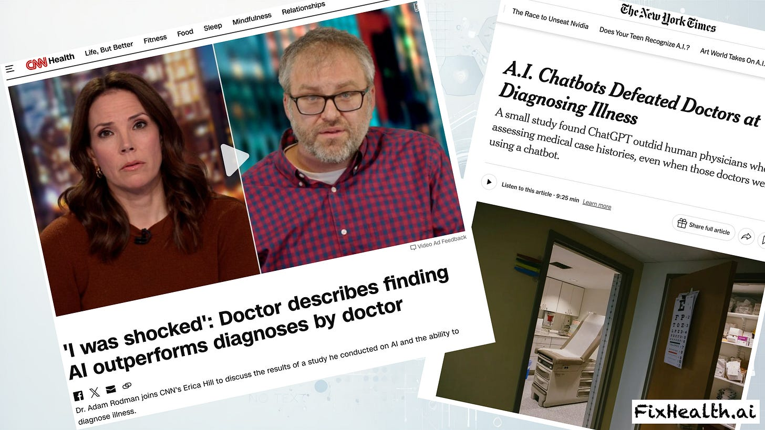

That is the Stanford study from JAMA Network Open, October 28, 2024. THE study. The one The New York Times converted into “A.I. Chatbots Defeated Doctors at Diagnosing Illness.” The one I dissected line by line in Part 2 of this series. The one where the entire “LLM alone” arm rested on 6(!!!) hand-picked vignettes out of an available 105, run 3 times each for a grand total of 18 data points. The one where “diagnostic reasoning” carried 78% of the score and the actual final diagnosis carried 11%. The one where the physicians received no training in prompting whatsoever, with one of the study’s own authors admitting the doctors could have used some. The one where the Stanford authors themselves later walked back the media framing, as I documented in Part 3.

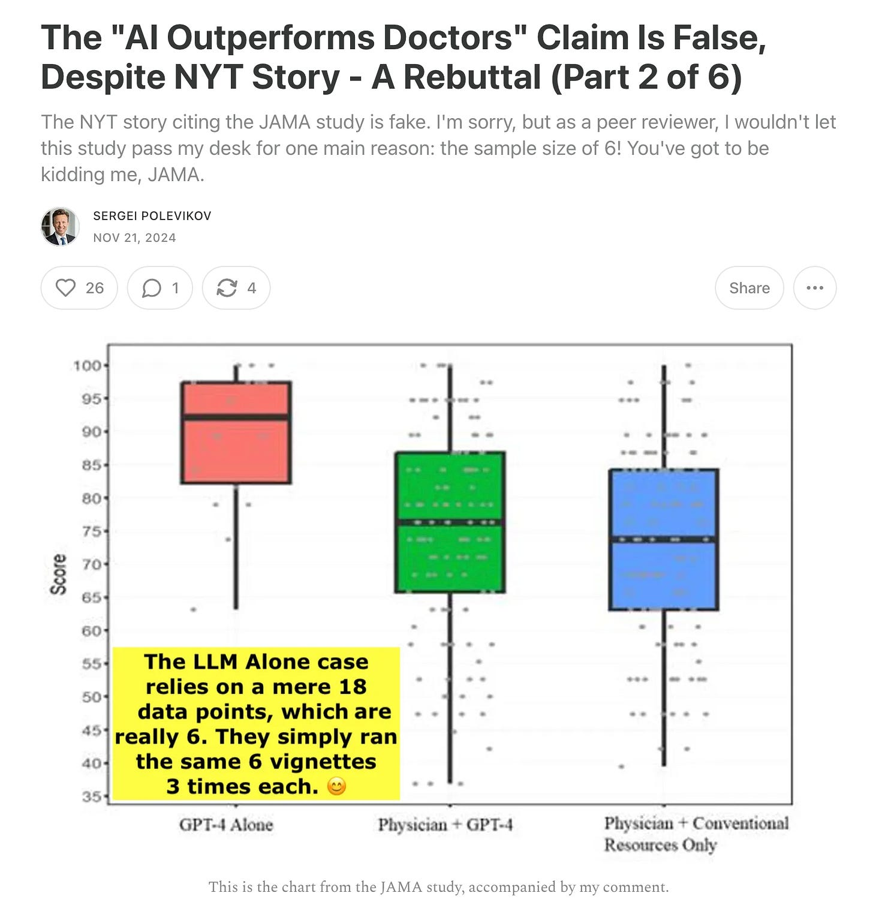

The Perspective calls these “real patient cases.” They were 6(!!!) written vignettes. Real patients do not arrive as vignettes. Ask any doctor who has tried to extract a medication history from a patient who describes everything as “the little white pill.”
21 months ago, this study couldn’t survive one angry statistician with a Substack. Now it anchors the hybrid-degradation thesis in JAMA. Nobody fixed the sample size in between. It’s still 6. 😊
And here is the best part. The Perspective notes that o1-preview, a reasoning model, scored 97% on the same cases, then admits in the very next sentence: “However, they did not conduct a direct comparison using o1-preview hybrids.” So for the model generation this entire argument depends on, there is NO hybrid comparison at all. The claim that humans degrade today’s best models is an extrapolation from 18 data points generated by a model that’s been obsolete since May 2024.
Is there something real underneath? Yes, and I’ll get to it in the Silver Linings (section 8 below), because automation bias, algorithm aversion, and deskilling are not jokes. But notice what the fair test would be: TRAINED physicians, with redesigned workflows, versus AI alone. The Perspective concedes, citing its own eTable, that “the design of hybrid workflows can affect hybrid performance, and there has been insufficient testing on which AI implementations are optimal.” Translation: we haven’t seriously tried to build good hybrids yet, but we’ve already concluded they can’t work. 🙄 As Dr. Graham Walker put it back in 2024: “This is like the early days of the internet, don’t assume doctors know how to use AI.” You don’t measure the ceiling of human-AI teamwork by handing a chatbot to someone who’s never used one and starting the clock.
In 2024, six vignettes couldn’t survive one angry statistician with a Substack. In 2026, they’re the load-bearing wall of a JAMA Perspective.

5. A Chess Blog Walks Into JAMA ♟️
Every “AI will replace professionals” essay is legally required to invoke chess, and this one delivers. Deep Blue beat Kasparov in 1997. The last human win against a top machine came in 2005. By 2017, AI alone had surpassed even the best human-AI “centaur” teams. Therefore, medicine.

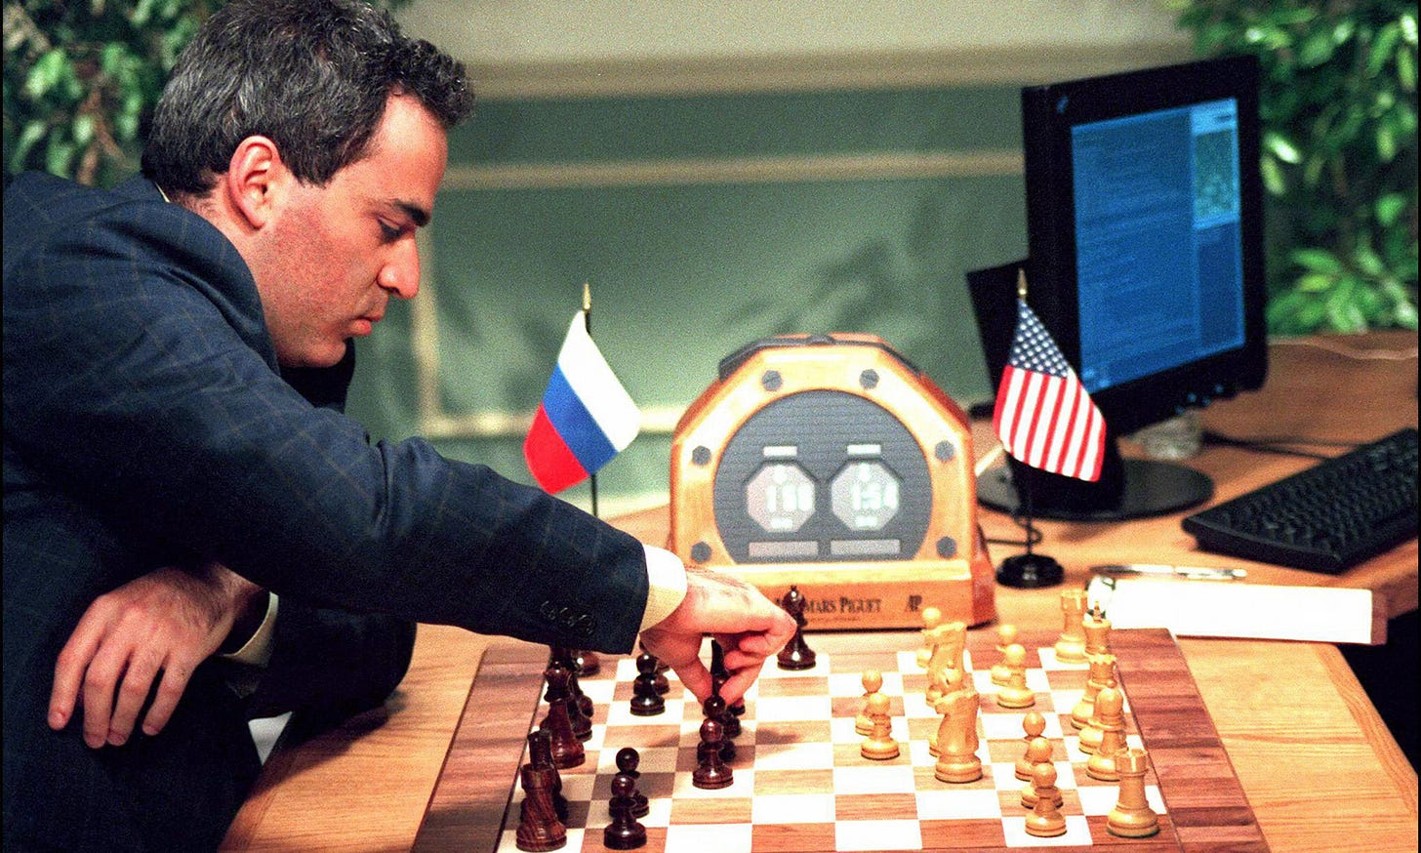
Photo credit: https://www.theguardian.com/sport/2021/feb/12/deep-blue-computer-beats-kasparov-chess-1996
The citation for this pivotal historical argument, reference 11, in the Journal of the American Medical Association, is a blog post. From a website called deepchess.org. Published in 2018.
The authors acknowledge, correctly, that “Medicine is more complex than chess. Physicians’ choices are less clearly defined and less certainly linked to outcomes.” And then they proceed as if they hadn’t written that sentence. But it’s the whole ballgame. Chess has perfect information, fixed rules, instant and uncontested ground truth, and zero liability. Medicine has incomplete information, a patient who forgot to mention the anticoagulant, lab errors, no-shows, comorbidities, and a ground truth that sometimes takes months and a pathologist to establish. When the machine blunders in chess, you lose a pawn. When it blunders in medicine, well, Doctors Go to Jail. Engineers Don’t. And an engineer’s model without a doctor? Nobody goes to jail. That should terrify you, not reassure you.
To be fair to the authors, their Caveats section is refreshingly candid. They admit most of their evidence comes from simulations of “discrete cognitive medical tasks, not analyses of real clinical interactions.” They admit adversarial stress testing shows LLMs “are still brittle.” They admit liability, regulation, and reimbursement barriers make real autonomous-AI studies scarce. And they admit publication bias exists, citing a study noting that “failures or negative outcomes of medical AI are often not formally reported,” before adding, with a straight face, “although this is changing as AI failures become more rare and notable.”
Read that again. Failures go unreported. Also, failures are becoming rare. Based on what? The reports we just agreed don’t exist? M.C. Escher would frame that paragraph. 😂

6. The Curai Sideshow: 91% of What, Exactly?
You may have noticed that the main text of this JAMA Perspective, co-authored by the CEO of Curai Health, does not cite Curai Health’s own headline study. An interesting act of restraint. On paper, anyway. On X, no such restraint. Hours after the paper went live yesterday, Neal posted a victory-lap thread that opens like this:

Neal Khosla@nealkhosla
1/ We started @CuraiHQ with the mission of proving AI could outperform humans at the core cognitive work of medicine. Today in @JAMA_current, @ZekeEmanuel, @AbeBakerButler, @vkhosla, and I are publishing a comprehensive argument this future is here.
jamanetwork.com
Will Autonomous AI Exceed AI-Aided Physicians as the Best Medical Care?

9:33 AM · Aug 17, 2026 · 94.9K Views

32 Replies · 17 Reposts · 97 Likes

Read that first sentence carefully. He did not start a company to ask whether AI can outperform humans. He started it with “the mission of proving” that it can. That distinction matters. It suggests the thesis preceded the evidence. The company, the preprint, and now the JAMA Perspective can therefore be read not as independent steps toward an open question, but as successive efforts to support a conclusion that had already been stated. Yesterday, that mission effectively acquired a DOI.
The doctors noticed, too. Within hours, the physician account Real Doc Speaks replied to Neal’s thread:

Real Doc Speaks@realdocspeaks
Congratulations, you are working on a solution to 6% of the cost of healthcare and ignoring the other 94%!
Neal Khosla @nealkhosla
1/ We started @CuraiHQ with the mission of proving AI could outperform humans at the core cognitive work of medicine. Today in @JAMA_Current, @ZekeEmanuel, @AbeBakerButler, @vkhosla, and I are publishing a comprehensive argument this future is here. https://t.co/bpXMdXljsw
2:02 PM · Aug 17, 2026 · 11.2K Views

7 Replies · 8 Reposts · 94 Likes

“Congratulations, you are working on a solution to 6% of the cost of healthcare and ignoring the other 94%!” However you slice the accounting, physician take-home pay is a single-digit share of the US healthcare dollar. The rest goes to hospitals, administrators, drugs, devices, and the billing-industrial complex this newsletter documents every week. Replace every doctor with a free chatbot tomorrow, and an MRI still costs $3,000 at a health system that just acquired its last competitor. To be fair, the Khosla pitch has always been about access as much as cost, and I grant them that in the Silver Linings (section 8) below. But note what yesterday’s paper is actually about. It’s a plan for the 6%. It has nothing to say about the 94.
Now, about that headline study the Perspective somehow forgot to cite. Allow me to fix the omission, because it completes the picture.

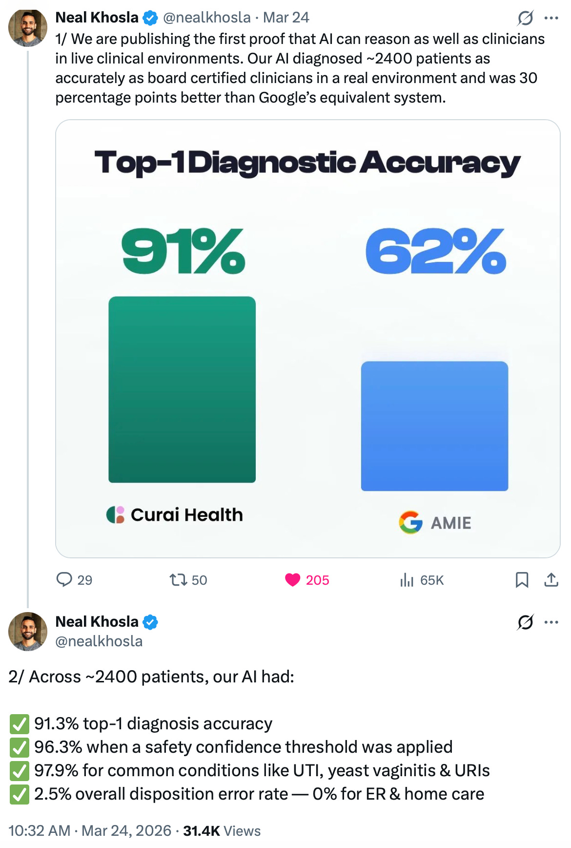
Neal’s March 24, 2026 thread: “the first proof that AI can reason as well as clinicians in live clinical environments.” Hold that thought.
On March 24, 2026, Neal Khosla announced “the first proof that AI can reason as well as clinicians in live clinical environments.” The claims: 91.3% top-1 diagnostic accuracy across roughly 2,400 patients, 96.3% with a safety confidence threshold, 97.9% for common conditions, a 2.5% disposition error rate, and “30 percentage points better than Google’s equivalent system.”
The source is a medRxiv preprint, posted days earlier. I read it so you don’t have to. Here’s what the tweet thread didn’t mention:
1️⃣ All five authors are Curai Health employees. Including the CEO, who is also an author on yesterday’s JAMA Perspective arguing that companies like his should replace physicians. No external funding, no external authors, no peer review. A company graded its own homework and tweeted the report card.
2️⃣ The “accuracy” is agreement with Curai’s own treating clinicians. The AI’s top-1 diagnosis “matched the clinician’s diagnosis” in 91.3% of 2,379 retrospective encounters. The ground truth is the human doctor’s call. Which means “AI diagnosed as accurately as board certified clinicians” literally translates to “AI agreed with our clinicians 91.3% of the time.” That is concordance, not accuracy. Nobody chased down what actually happened to the patients.
3️⃣ The grading was done by a structured LLM evaluation prompt. An AI judged whether the AI agreed with the humans. The circle of life. 🦁
4️⃣ The 96.3% “with a safety confidence threshold” comes with no deferral denominator in the headline. Any model can hit 96% if it’s allowed to skip the hard cases. The interesting number is how many cases it skipped. That number is not in the tweet.
5️⃣ The 97.9% is for UTIs, yeast vaginitis, and URIs. Automating the strep-throat-and-UTI visit is useful. I mean that sincerely, and I’ll say more in the Silver Linings (section 8 below). But it is not “proof that AI can reason as well as clinicians.” It’s proof that protocolized low-acuity telehealth is protocolizable. We knew that.
Concordance is not accuracy. When your gold standard is the doctor’s answer, agreeing with the doctor is your ceiling, and “as good as the doctor” is your victory condition. You cannot beat the ruler you’re measuring with.

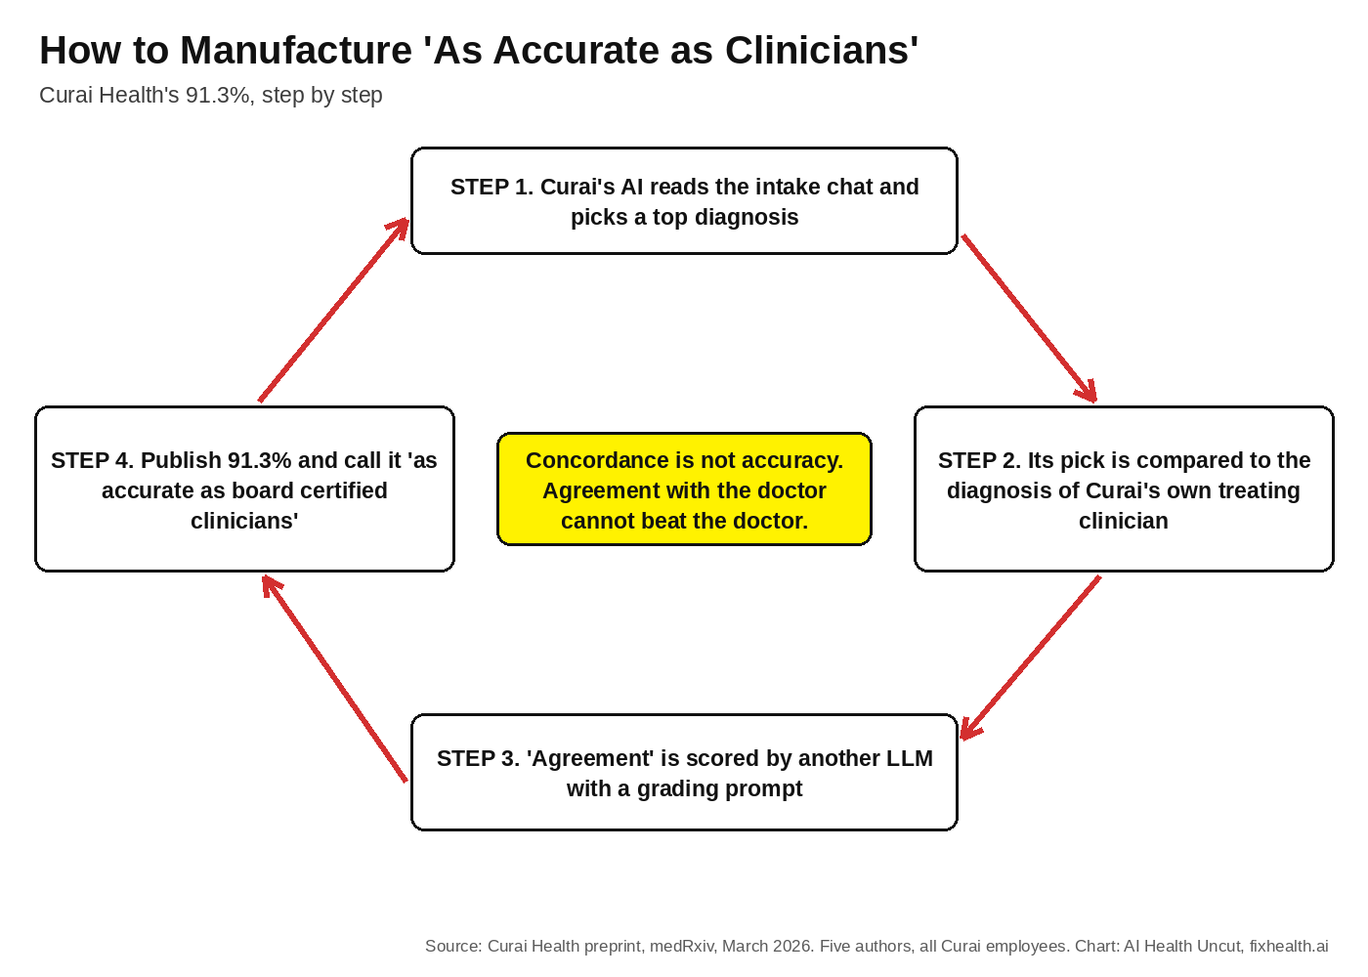
The full circle of life in one diagram. At no point does anyone check what happened to the patient.
And the bar chart. Oh, the bar chart. Curai’s 91% (concordance with its own clinicians, on its own telehealth population, heavy on simple conditions, graded by its own LLM prompt) standing next to AMIE’s 62% (Google’s real-world Beth Israel study actually reported 56% top-1, against adjudicated final diagnoses, on an academic primary care population, but who’s counting) next to a 33% “OpenAI” disposition error rate from yet another setting. Three different studies. Three different populations. Three different definitions of ground truth. One triumphant chart.

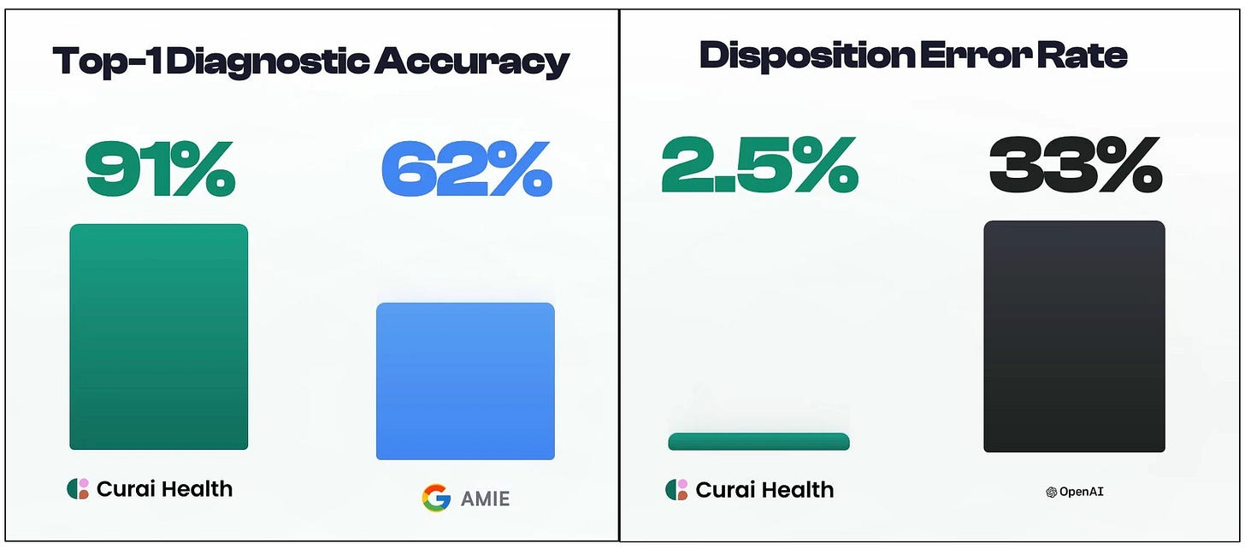
The charts from Neal’s thread, in their original glory. Every bar comes from a different study, a different population, and a different definition of correct.
Where have I seen this move before? Right: Hippocratic AI’s benchmark chart in Part 4, where Polaris 2.0 crushed everyone on Hippocratic’s own proprietary benchmark that no outside soul has ever run. As I said then: beating everyone on your own benchmark, fine-tuned on your own dataset. Wow. You must be so proud. 🙄

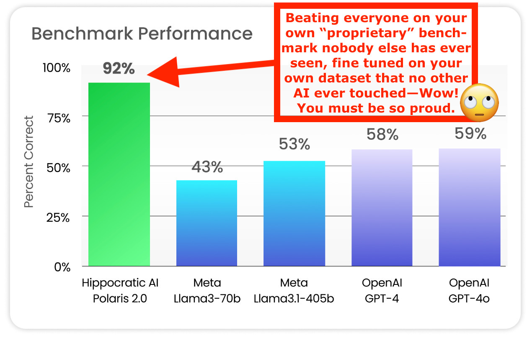

The pattern deserves a name, so here it is: benchmark theater. And yesterday it graduated from tweet threads to the references of America’s flagship medical journal.

7. Emanuel vs. Emanuel, and 14 Years of Khosla Predictions
Regular readers met Ezekiel “Zeke” Emanuel in Part 4, where he appeared as power player number 5 with this November 22, 2017 gem, via The Wall Street Journal:

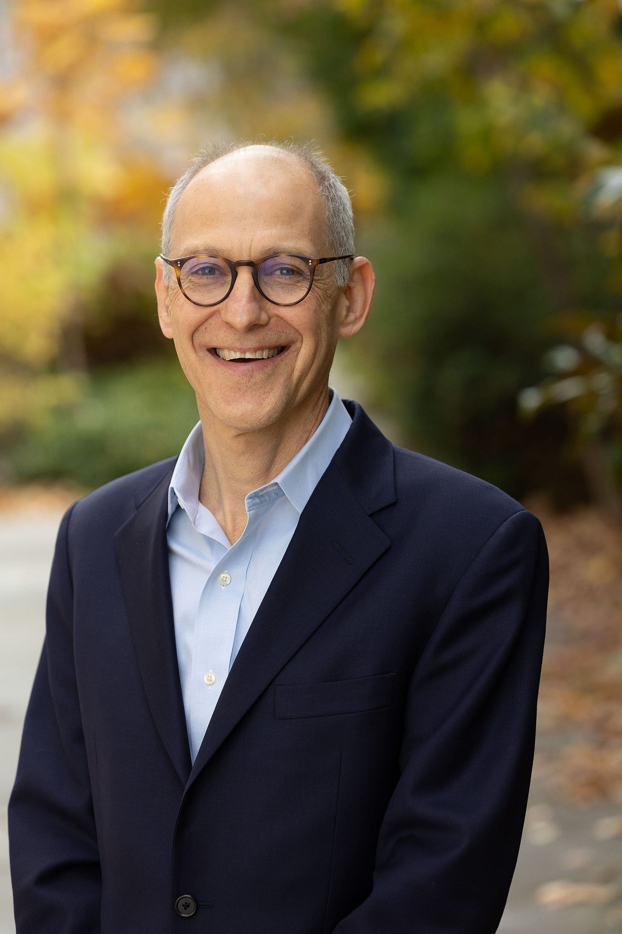
Ezekiel “Zeke” Emanuel
“Machine learning will replace radiologists and pathologists, interpreting billions of digital X-rays, CT and MRI scans and identifying abnormalities in pathology slides more reliably than humans.”
—Ezekiel J. “Zeke” Emanuel, MD, Ph.D., November 22, 2017
Almost nine years later, radiologists have not been replaced. We’re facing radiologist shortages worldwide, as I documented in Part 4. Even yesterday’s Perspective quietly concedes the point, excluding radiology as “a domain in which AI alone does not reliably exceed physicians.” The one specialty everyone guaranteed would fall first is the one specialty the replacement crowd now writes out of its own thesis. No apology, no postmortem, just a silent asterisk.
But my favorite Emanuel artifact is from June 2019, when he co-authored a JAMA piece titled “Artificial Intelligence in Health Care: Will the Value Match the Hype?“ A skeptical take, urging caution about inflated claims. His co-author? Robert Wachter. The same Robert Wachter whose book yesterday’s Perspective spends its opening paragraph dismantling.
In 2019, Emanuel and Wachter stood together asking whether the value would match the hype. In 2026, Emanuel is supplying the hype, and Wachter is the strawman. What changed? The models got better, absolutely. But the co-author line changed too. It now reads Khosla and Khosla. Follow the co-authors.

As for Vinod, “The Forecaster Without the Horizon,” here’s the abridged timeline I assembled in Part 4, updated for 2026:

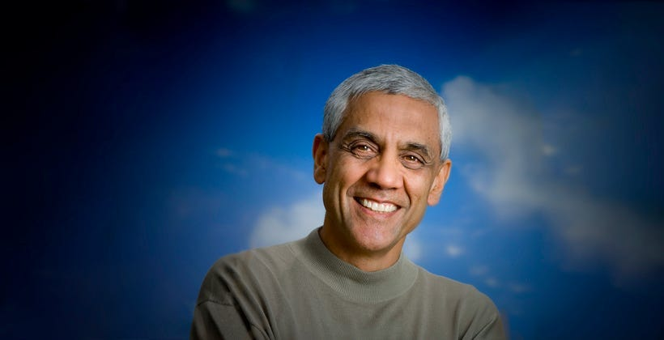
Vinod Khosla
- 2012: “Doctors can be replaced by software. 80% of them can, maybe more, possibly more, probably more, but at least 80% can.” And: “Eventually we won’t need the doctor.”

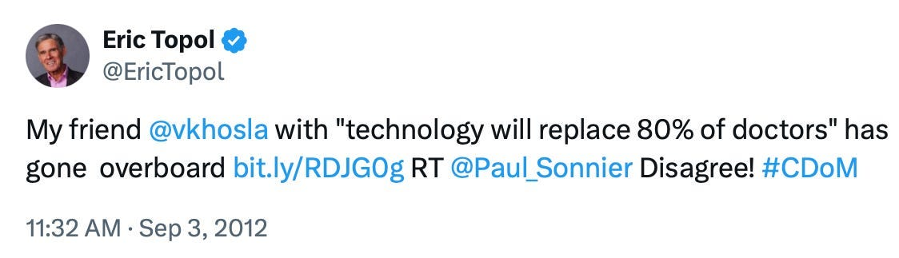

- 2016: The “20-Percent Doctor Included“ manifesto. 80% of physicians’ standard work, displaced.

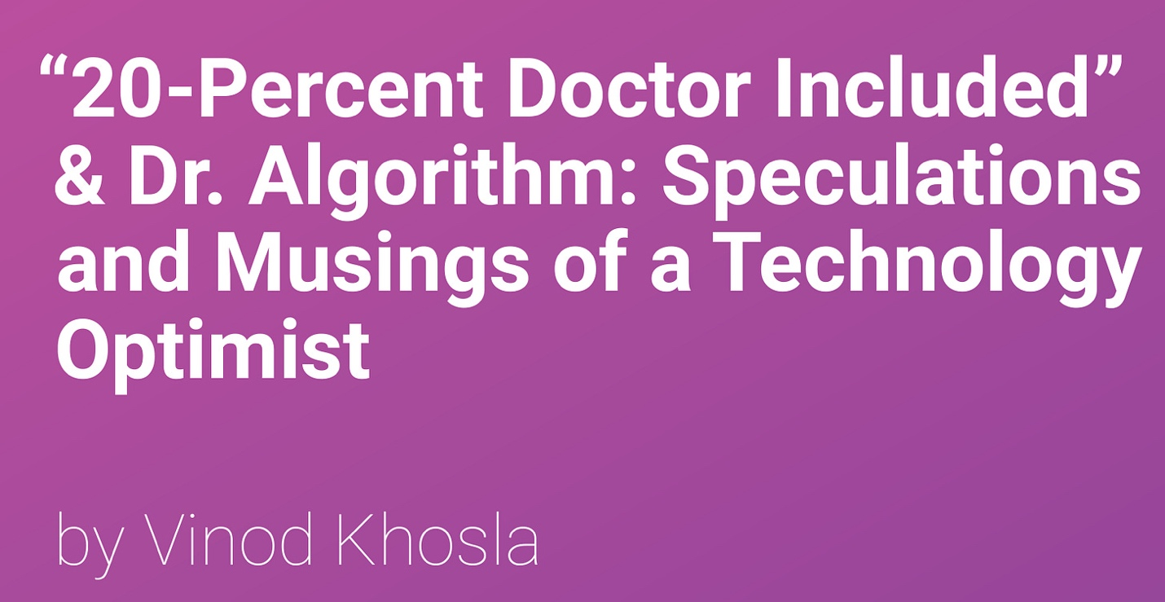

- 2017: “The role of the radiologist will be obsolete in five years.” (The five years ended in 2022. Radiologists missed the memo.)
- 2018: “Dr House will be an AI [app], and everybody will have a free version.” Said in an interview conducted by, I kid you not, Eric Topol.
- 2023: Within 5 to 6 years, the FDA will approve a primary care app qualified to practice like your PCP.
- September 2024: AI will do 80% of the work in 80% of all jobs within 25 years.
- January 2026: “Studies show AI outperforming doctors in both diagnostic accuracy and empathy across several specialties… When machines exceed human performance on skill and bedside manner, the future will arrive faster than expected.“
- August 2026: The prediction gets a DOI.

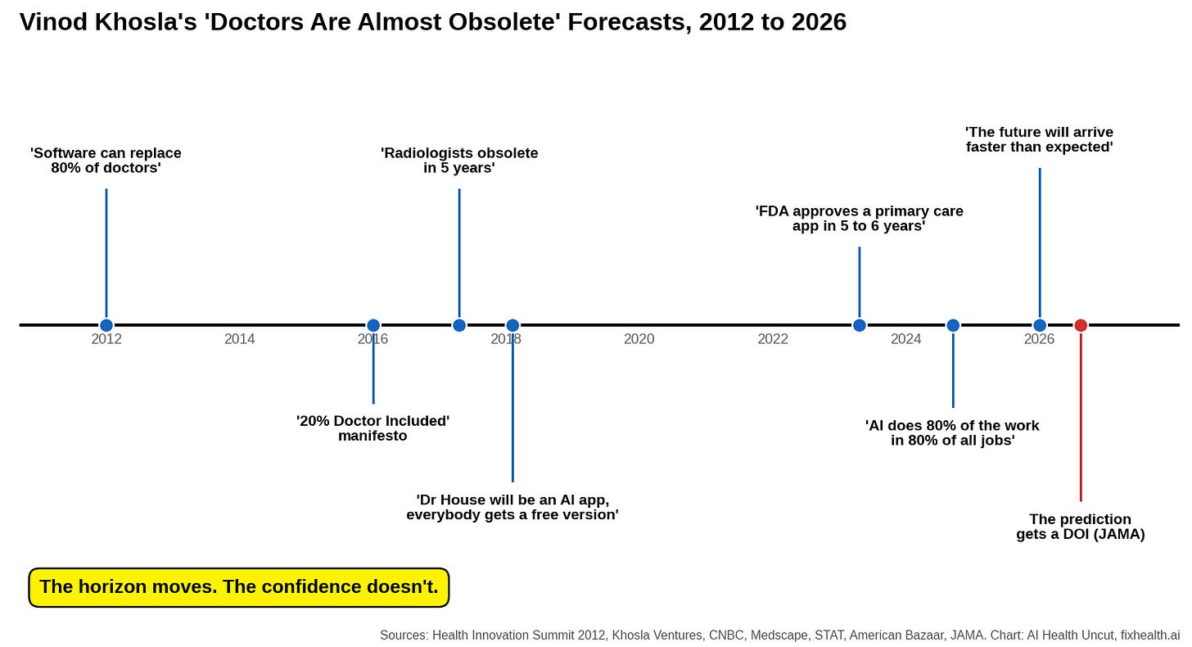
14 years on one line. The red dot is the JAMA paper.
14 years of the same forecast, each time 5 years away. As I wrote in Part 4: if you repeat the same prediction for decades and it eventually comes true, do you even get credit? The horizon keeps moving. The confidence never does. Nassim Taleb built a whole brand on this trick, and at least he only “predicts” market crashes.
To be fair, “by 2030” is at least falsifiable. I’ve put it in my calendar. See you on January 1, 2031, gentlemen. 📅

8. Silver Linings: Where the Authors Are Right
Now for the part that will get me yelled at by both camps, which is how I know it’s right. 😉
The trajectory is real. The jump from GPT-4 to reasoning models on cognitively demanding tasks is not hype, it’s measurable, and it’s fast. I said it at the end of Part 4 and I’ll say it again: transformer-based LLMs as they exist today will never fully replace doctors, but the next generation might, and we’re closer than many in medicine want to believe.
If your entire rebuttal to this JAMA piece is “AI can’t do medicine,” you’re as wrong as the authors, just in the opposite direction and with worse funding.
The hybrid critique contains a hard truth. Handing an untrained doctor a chatbot and expecting synergy is fantasy, and even the flawed 6-vignette study showed it: physicians with GPT-4 scored 76% versus 74% without. Two points. Automation bias is real. Algorithm aversion is real. And deskilling is terrifyingly real. The Lancet Gastroenterology & Hepatology study cited by the authors found that endoscopists’ adenoma detection rates actually DROPPED after routine exposure to AI. That finding should keep every dean of medical education up at night, and as far as I can tell, most of them are sleeping fine. The Perspective is right that “hybrid care is automatically better” is an assumption, not a finding. Physicians who plan to survive the next decade need actual training in when to trust, when to override, and how to audit these systems. Almost nobody is teaching that today.
The AMA and ACP are asserting, too. Let’s be honest about the other side. “AI should be limited to a supportive role” is also an evidence-free position. It’s dogma versus dogma, guild versus capital. Neither side has the prospective randomized trials to prove its story. The difference is that one side admits what it’s selling.
And the access crisis is not a debating point. America is living through the worst physician and nurse shortage in its history. Tens of millions of people have no realistic access to primary care at all. Their real-world comparator is not a Norman Rockwell physician with 45 unhurried minutes. It’s a phone tree, a 6-week wait, or nothing. As I wrote in Part 4: a verified AI model with a low error rate, one that can address patient needs especially in rural areas, is 100 times better than a desperate call landing in a voicemail abyss. Utah is already running the experiment, licensing AI for prescription renewals, a program the authors themselves cite, and which I examined in my Doctronic investigation. Autonomous AI for narrow, protocolized, low-acuity care, with hard guardrails, honest audit trails, and a clear escalation path? Sign me up. Curai’s 97.9% on UTIs points at exactly that future, and it’s a future worth building.
So when the authors write that AI-alone care exceeding physicians at cognitive tasks “is unsettling but seems probable,” I don’t clutch a stethoscope I don’t own. Directionally, they may well be right. That’s precisely why the case deserves better evidence than OSCE role-play, 6 vignettes, and a chess blog.
The destination might be right. The map is drawn in crayon. And the cartographers own the toll road.

9. My Peer Reviewer Wish List
Putting on my peer reviewer hat, as I did in Part 2. Here’s what would move this debate from marketing to medicine. Authors of the Perspective, consider this a free consult. The first one’s on me. 😉
1️⃣ Prospective, preregistered trials on real patients. AI alone versus physician alone versus TRAINED physician-AI teams, with pre-specified endpoints, published win or lose. Google announced a nationwide randomized study of AI in real-world virtual care in February 2026, and the authors cite it. That’s the right shape. Now guarantee independent evaluators and publication regardless of result.
2️⃣ Ground truth must be outcomes, not agreement. Adjudicated diagnoses and 30-day and 90-day outcomes. Not concordance with the treating clinician, which caps you at a tie with the humans you claim to beat. And not LLM-graded rubrics. If the referee is a model, the score is a simulation.
3️⃣ Report the deferral denominator. Every confidence-thresholded accuracy figure must come with the percentage of cases the AI declined. 96.3% on the cases you chose to answer is a different ball game from 96.3% on the cases that walked in the door.
4️⃣ Report the case mix. Stratify by acuity and prevalence. A system that’s brilliant at UTIs and lost at heart failure with atypical presentation should be described as exactly that, not averaged into a highlight reel.
5️⃣ Liability first, deployment second. As I’ve been saying for years: even if AI achieves 99.999% accuracy in medicine, it doesn’t matter until we define who takes the fall when things go wrong, within and outside the standard of care. Utah’s experiment matters more than any benchmark because it’s the first serious attempt to answer that question. Doctors go to jail. Engineers don’t. Autonomous AI without a liability regime is a lawsuit with a loading screen.
6️⃣ Statisticians on the byline. And please please 🙏 : at least one author whose net worth does not move with the conclusion. The flawed 6-vignette study had 16 co-authors and apparently not a single statistician. This Perspective has four co-authors, three of whom disclose financial ties to the industry whose victory they’re forecasting. Medicine can do better than choosing between innumeracy and equity stakes.

10. Conclusion
Let’s give the devil his due, then take it back.
“Will Autonomous AI Exceed AI-Aided Physicians as the Best Medical Care?” is the right question. It’s THE question, the one I’ve spent two years and four parts of a six-part series on, from Warner Slack in 1955 to Geoffrey Hinton’s Wile E. Coyote radiologists. And the authors are right that the medical establishment’s answer (”AI shall forever remain a humble assistant”) is a wish wearing a policy costume.

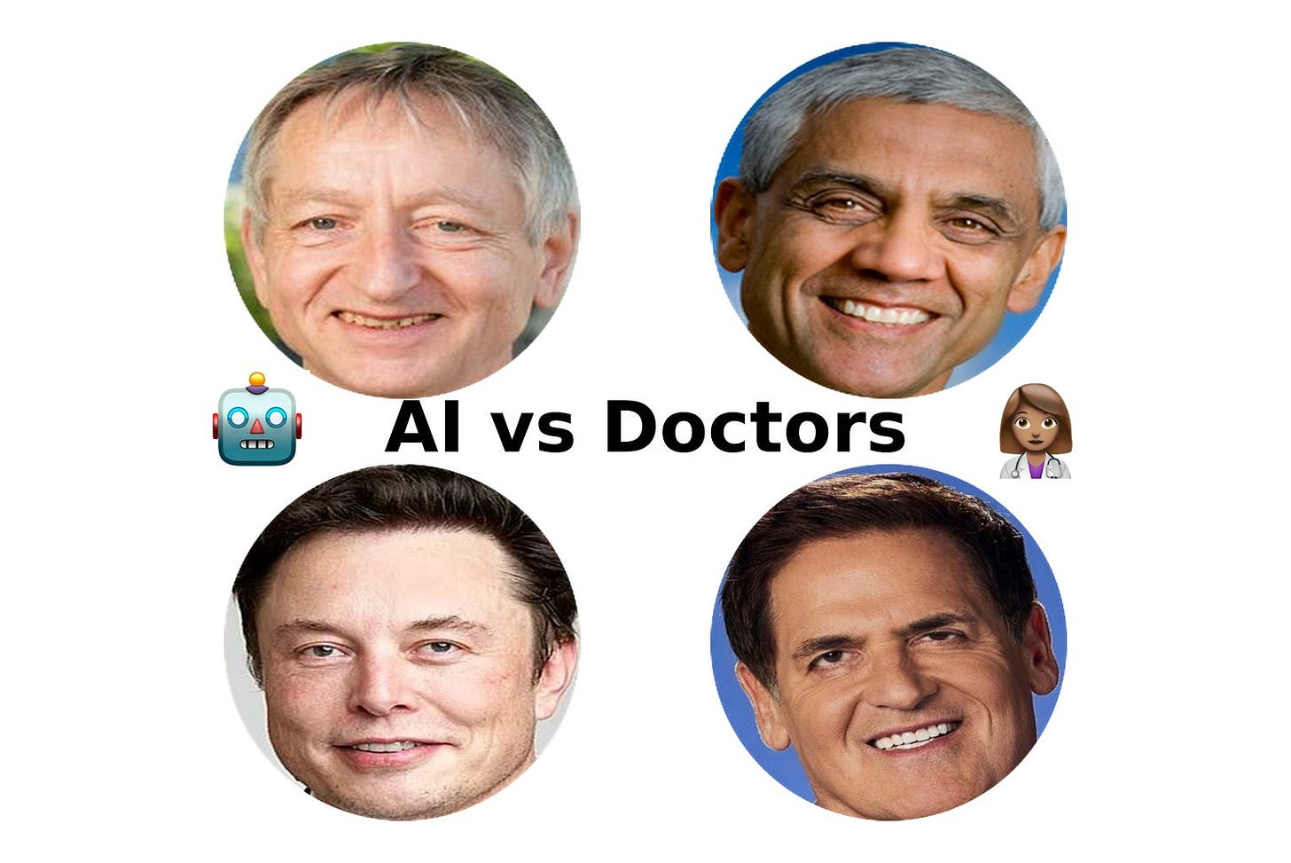
I’m biased, of course. But I think Part 1 of this series is a must-read for anyone who wants an introduction to the 70-year “AI vs. Doctors” debate.
But look at what was actually published yesterday in the world’s most influential medical journal. A father who invests in OpenAI and Curai. A son who runs Curai and holds a pending patent on autonomous-AI verification. An oncologist/bioethicist with a decade in venture capital and a disclosure section longer than some abstracts. Together they assembled simulated OSCE encounters, a 6-vignette study that collapsed under scrutiny 21 months ago, a one-month chart review comparing suggestions to decisions, a 32-patient insulin trial, a meta-analysis of mostly non-medical experiments, and a chess blog, and they concluded that the humans should be removed from the loop, ideally by 2030, a timeline the family patriarch has been promising since 2012.
Sure, maybe history will vindicate the thesis. I’ve said myself that autonomous AI diagnosis is coming, that medicine’s denial is a bigger danger than medicine’s disruption, and that patients stuck in the voicemail abyss can’t wait for perfect. (I’ve personally been working on the latter problem for almost 7 years now.) But validity requires a foundation of facts. When the referee is an LLM, the gold standard is the very doctor you’re replacing, and the evidence base doubles as the authors’ portfolio, that’s not science compounding. That’s marketing compounding.
AI will replace doctors. Some of what they do, sooner than doctors think. All of what they do, much later than the Khoslas have been promising since 2012. And the people who finally prove it will have no term sheet riding on the answer.
I invite the authors, all four of them, to join the conversation. Zeke, Abe, Neal, Vinod: my inbox is open, my comment section is unmoderated, and unlike JAMA, I don’t charge submission fees. If I’ve crossed a line or botched my reading of your paper, I’ll own up to it. At the end of the day, I’m just a guy from a third-world country, sitting in a hot, smelly basement, trying to make sense of it all. What do I know, right? 😉
All right, that’s a wrap.
As a reminder, here’s the full “Will AI Replace Doctors?” series:
The ‘🤖 machines will replace doctors 👩🏽‍⚕️’ debate turns 70! From Warner Slack to Geoffrey Hinton. (Part 1 of 6)
The “AI Outperforms Doctors” Claim Is False, Despite NYT Story - A Rebuttal (Part 2 of 6)
The NYT Says AI Doctors Are More Accurate—Time to Fire Your PCP? (Part 3 of 6)
These 13 Power Players and 9 AI Companies Think Doctors Are on the Way Out (Part 4 of 6)

Like what you’re reading in this newsletter? Want more in-depth investigations and research? Alright then—go tell your friends!
Share

👉👉👉👉👉 Hi! My name is Sergei Polevikov. I’m an AI researcher and a healthcare AI startup founder. In my newsletter ‘AI Health Uncut,’ I combine my knowledge of AI models with my unique skills in analyzing the financial health of digital health companies. Why “Uncut”? Because I never sugarcoat or filter the hard truth. I don’t play games, I don’t work for anyone, and therefore, with your support, I produce the most original, the most unbiased, the most unapologetic research in AI, innovation, and healthcare. Thank you for your support of my work. You’re part of a vibrant community of healthcare AI enthusiasts! Your engagement matters. 🙏🙏🙏🙏🙏

